1b-3 File Search, Analysis & Archiving in Linux

Class Activity Overview
This lab trains students in using command-line tools to locate, inspect, and search through text files, especially within large archives. It builds essential skills in system administration and file forensics using Linux.

Learning Objectives
- - Extract compressed archive files using bunzip2 and tar.
- - Search for files by name, extension, and content using find and grep.
- - Understand and apply file modification and creation timestamp analysis.
- - Locate files by size and frequency of use.
- - Use sed, sort, and uniq to explore data trends in large files.
- - Answer analytical questions using Linux command-line tools.

Lab Setup and Steps
- - Download `gutenberg.tar.bz2` from LMS.
- - Extract with: `bunzip2 gutenberg.tar.bz2` then `tar -xvf gutenberg.tar`.
- - Explore contents: `ls -l`, `tree`, or use `less` to inspect a few files.
- 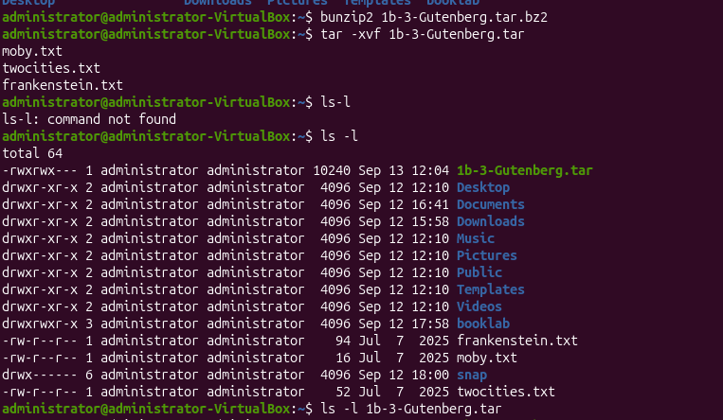
- - Search for filenames: `find ./Gutenberg -name "*.txt"`.
- 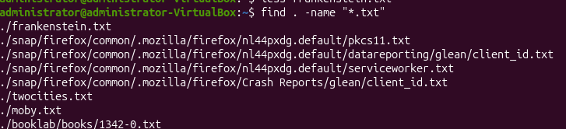
- - Search for strings: `grep -r 'keyword' ./Gutenberg` or use `find -exec grep`.
- 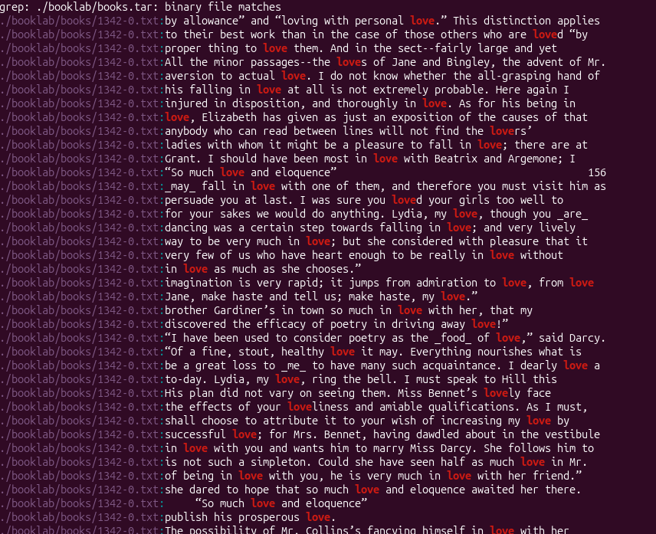
- - Search with context: `grep -r -C 3 'Next day' ./Gutenberg`.
- 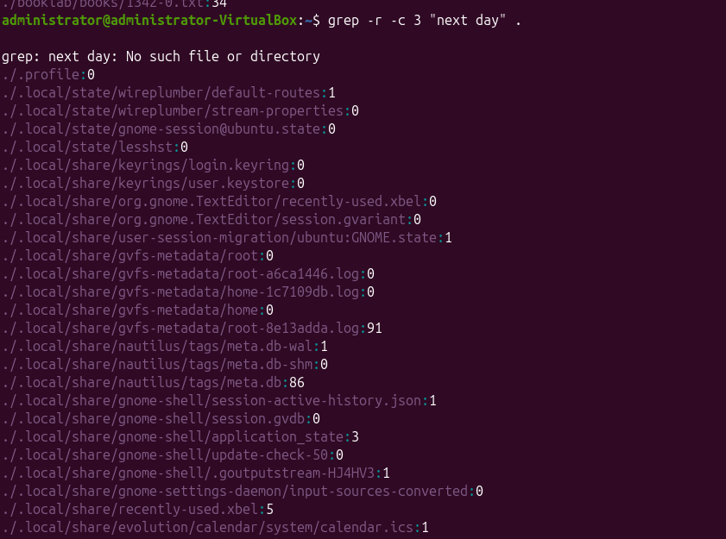
- - Search by size: `find ./Gutenberg -type f -size 255258c -exec ls -lh {} \;`.

- - Search by creation/modification date: `find -type f -printf '%T+ %p\n' | sort`.
- 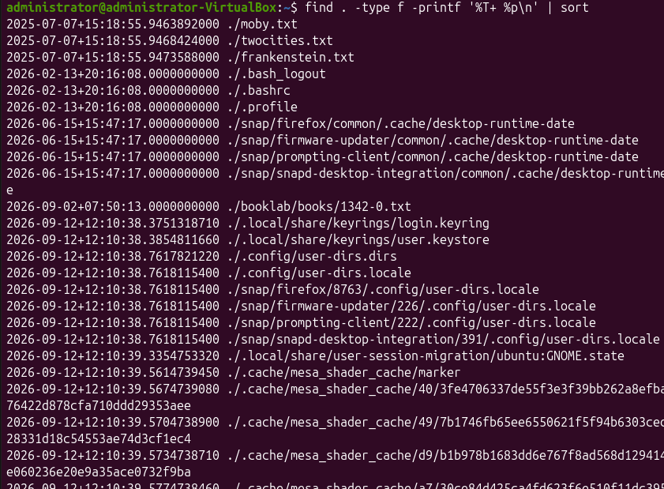
- - Find largest files: `du -a ./Gutenberg | sort -nr | head`.
- 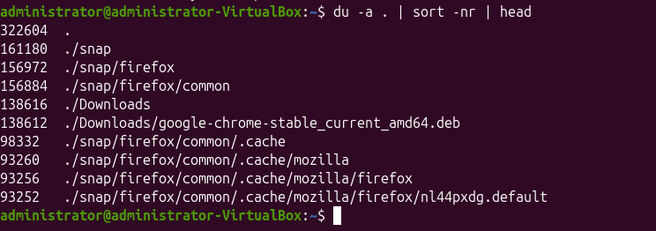
- - Analyze frequency in files: `sed -e 's/\s/\n/g' < file.txt | sort | uniq -c | sort -nr | head -200`.

Analytical Questions to Answer
- - How many times does the string “verdigris” appear? (enter a number only)
- - What is the surname of the author of the filename “1107.txt”? (case sensitive)
- - What is the surname of the author of the file that is exactly 255258 bytes? (case sensitive)
- - What is the filename of the file with the 3rd oldest creation date?
- - Find the word that follows the text: “Next day there was a surprise for Jack” (Case-sensitive, no spaces)

Reflection Prompts
- - Which command-line tool was the most useful in solving the questions?
- - How might these search tools help in cybersecurity investigations?
- - How could scripting improve repetitive search tasks?
- - What limitations did you encounter using grep and find?

1. Which command-line tool was the most useful in solving the questions?

I found grep the most useful because it allowed me to search through the contents of many files quickly. It was especially useful for finding specific words or phrases and for showing surrounding lines with options such as -C 3. find was also useful for locating files by name, size, and modification time.

2. How might these search tools help in cybersecurity investigations?

Tools such as grep, find, du, and sort can help investigators search large numbers of files efficiently. For example, grep can be used to look for suspicious usernames, IP addresses, error messages, or indicators of compromise inside logs. find can locate recently modified files, unusually large files, or files with suspicious names. These tools can help narrow down where to investigate further.

3. How could scripting improve repetitive search tasks?

Scripting can combine multiple commands into one repeatable process. Instead of manually running the same searches on many files, a shell script could automatically search for keywords, list recently modified files, identify large files, and save the results into a report. This would make investigations faster, more consistent, and less prone to human error.

4. What limitations did you encounter using grep and find?

grep is very useful for text files, but it is less suitable for binary files or complex data formats. Searches can also be case-sensitive unless options such as -i are used, and broad recursive searches can produce a lot of unwanted output.
find is powerful for locating files based on names and file properties, but its syntax can be difficult to remember. It also searches metadata and filenames rather than the actual contents of files, so it often needs to be combined with grep for content searches.

🔎 Activity: File Extraction, Searching & Pattern Analysis (Gutenberg Archive)
📘 Objective
Learn to extract compressed archives and apply advanced command-line file search techniques (by filename, content, date, size) to solve real problems on a Linux filesystem.

📦 Deliverables
# | Deliverable | Description
✅ 1 | Archive Extracted Successfully | Screenshot or terminal log of:  • bunzip2 Gutenberg.tar.bz2  • tar -xvf Gutenberg.tar
✅ 2 | File Listing of Extracted Directory | Output of ls -l or tree structure showing contents of extracted files (confirming successful extraction).
✅ 3 | Filename Search Demonstrated | Command and result for:  • find . -name "*.txt" or similar extension-based search
✅ 4 | Text Search via Grep | Output and command used for:  • grep -r "verdigris" . or equivalent
✅ 5 | Contextual Text Search | Output of grep -r -C 3 "Next day there was a surprise for Jack" . showing the following word
✅ 6 | Date-Based File Searches | Outputs and commands for:  • 3rd oldest file: `find ... -printf '%T+ %p\n'
✅ 7 | Size-Based File Searches | Output of:  • find . -type f -size 255258c -exec ls -lh {} \; (or similar)  • Search for files +512k in size
✅ 8 | Largest Files Found | Output of:  • `du -a .
✅ 9 | Text Frequency Analysis Performed | Output of:  • `sed -e 's/\s/\n/g' < file.txt
✅ 10 | Answers to Questions Provided | All 5 questions answered:  • "verdigris" count  • Author surname of 1107.txt  • Author of file that is 255258 bytes  • 3rd oldest file by creation date  • Word following "Next day there was a surprise for Jack"

📝 Suggested Submission Format
- .zip file containing:
  - Screenshot or .txt log of terminal outputs
  - A file named answers.txt or lab_responses.md with answers to the 5 spoiler questions
  - Optional: .sh file with all search commands used

